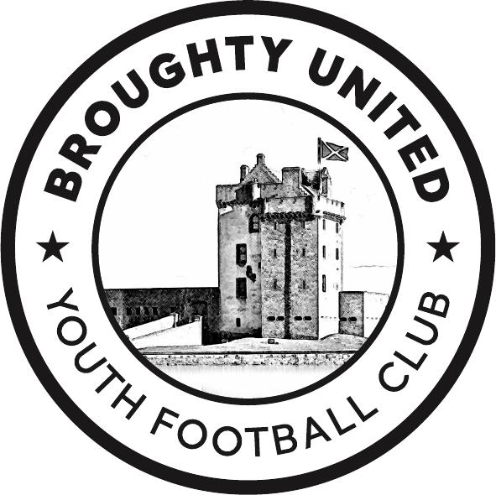
Child Wellbeing and Protection
Policy
Broughty United Community Club SCIO
Last updated | 27/07/2024

The purpose of this policy statement is:
- to protect children and young people who receive our services from harm. This includes the children of adults who use our services
- to provide staff and volunteers, as well as children and young people and their families, with the overarching principles that guide our approach to child protection.
This policy applies to anyone working on behalf of Broughty United Youth Club including the board of trustees, paid staff, volunteers, sessional workers, agency staff and students.

Legal framework
This policy has been drawn up on the basis of legislation, policy and guidance that seeks to protect children in Scotland.

We will also follow the Scottish FA Child Wellbeing and Protection Policy

Children's Rights & Wellbeing | Football Governance | Scottish FA

Supporting documents
This policy statement should be read alongside our organisational policies, procedures, guidance and other related documents.
- Health and Safety Policy
- Social Media Policy
- Coaches Code of Conduct
- Player and Supporter Code of Conduct
- Complaints Process

We believe that:
- Children and young people should never experience abuse of any kind
- We have a responsibility to promote the welfare of all children and young people, to keep them safe and to practise in a way that protects them.

We recognise that:
- the welfare of children is paramount in all the work we do and in all the decisions we take all children, regardless of age, disability, gender reassignment, race, religion or belief, sex, or sexual orientation have an equal right to protection from all types of harm or abuse
- some children are additionally vulnerable because of the impact of previous experiences, their level of dependency, communication needs or other issues
- working in partnership with children, young people, their parents, carers and other agencies is essential in promoting young people’s welfare.

We will seek to keep children and young people safe by:
- valuing, listening to and respecting them
- appointing a nominated trustee as child protection lead for children and young people
- adopting child protection and safeguarding best practice through our policies, procedures and code of conduct for staff and volunteers
- maintaining an effective social media policy and related procedures
- providing effective management for staff and volunteers through supervision, support, training and quality assurance measures so that all staff and volunteers know about and follow our policies, procedures and behaviour codes confidently and competently
- recruiting and selecting staff and volunteers safely, ensuring all necessary checks are made
- recording, storing and using information professionally and securely, in line with data protection legislation and guidance
- making sure that children, young people and their families know where to go for help if they have a concern
- using our safeguarding and child protection procedures to share concerns and relevant information with agencies who need to know, and involving children, young people, parents, families and carers appropriately
- using our procedures to manage any allegations against staff and volunteers appropriately
- creating and maintaining an anti-bullying environment and ensuring that we have a policy and procedure to help us deal effectively with any bullying that does arise
- ensuring that we have effective complaints and whistleblowing measures in place
- ensuring that we provide a safe physical environment for our children, young people, staff and volunteers, by applying health and safety measures in accordance with the law and regulatory guidance
- building a safeguarding culture where staff and volunteers, children, young people and their families, treat each other with respect and are comfortable about sharing concerns

END OF POLICY

